Md.Imran Ahmed

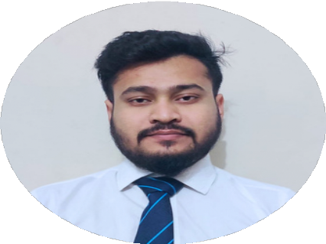

**CONTACT ME**

01626759580

[imranicon01@gmail.com](mailto:imranicon01@gmail.com)

Babur Jayga,Khilgaon,Dhaka-1219

**SKILLS**

MS Word, MS Excel, Powerpoint Communication

Team Work Leadership

Project Management

Problem Solving Test Case Design Test Documentation

Functional & non-functional Testing

Agile Methodologies Software Quality Assurance

# Personal Statement

I am excited to embark on a rewarding journey as a Manual Tester, harnessing my keen eye for detail, strong analytical skills, and systematic approach to problem-solving. My passion lies in ensuring the highest quality of software products by meticulously testing and validating every aspect of their functionality. I thrive on collaborating with diverse teams to deliver flawless results and exceed client expectations. My primary goal is to contribute to the success of a dynamic organization, while also advancing my expertise in manual testing and making a positive impact on the software development process.

# Personal Interest

Technology and Innovation Travel and Exploration



# Projects

# Book Borrowing Management System

# Platform : Web

# Technology:HTML,CSS,JavaScript,AJAX,MySQL,MVC

# Link:https://github.com/imrancaptain/Project/

# TRAVEL AGENCY MANAGEMENT SYSTEM

# Platform : Software Development

# Technology :

# Link:

# Education

Fitness and Outdoor Activities Photography

**B.Sc in ComputerScience and Engineering** American International University- Bangladesh 2020-2024 || CGPA : 3.09

## Higher Secondary Certificate (HSC)

Quality Education College 2017 || GPA : 4.42

## Secondary School Certificate (SSC)

Dakhin Banasree.M.High School 2015 || GPA: 4.72

# REFERENCES

## Akinul Islam Jony

Department Head of Computer Science, American International University Bangladesh Email: [akinul@aiub.edu](mailto:akinul@aiub.edu)